Chapter 13
The Costs of Production
Multiple Choice
1. According to the law of supply,
a. firms’ production levels are not correlated with the price of a good.
b. the supply curve slopes downward.
c. firms are willing to produce a greater quantity of a good when the price of the good is higher.
d. None of the above are correct.
ANSWER: c. firms are willing to produce a greater quantity of a good when the price of the good is higher.
TYPE: M DIFFICULTY: 2 SECTION: 13.1
2. Industrial organization is the study of how
a. labor unions organize workers in industries.
b. profitable firms are in organized industries.
c. industries organize for political advantage.
d. firms’ decisions regarding prices and quantities depend on the market conditions they face.
ANSWER: d. firms’ decisions regarding prices and quantities depend on the market conditions they face.
TYPE: M DIFFICULTY: 1 SECTION: 13.1
3. Economists normally assume that the goal of a firm is to
(i) sell as much of their product as possible.
(ii) set the price of their product as high as possible.
(iii) maximize profit.
a. (i) and (ii)
b. (ii) and (iii)
c. (iii) only
d. All of the above are correct.
ANSWER: c. (iii) only
TYPE: M DIFFICULTY: 2 SECTION: 13.1
4. The amount of money that a firm receives from the sale of its output is called
a. total gross profit.
b. total net profit.
c. total revenue.
d. net revenue.
ANSWER: c. total revenue.
TYPE: M DIFFICULTY: 1 SECTION: 13.1
5. The amount of money that a firm pays to buy inputs is called
a. total cost.
b. variable cost.
c. marginal cost.
d. fixed cost.
ANSWER: a. total cost.
TYPE: M DIFFICULTY: 1 SECTION: 13.1
6. Profit is defined as
a. net revenue minus depreciation.
b. total revenue minus total cost.
c. average revenue minus average total cost.
d. marginal revenue minus marginal cost.
ANSWER: b. total revenue minus total cost.
TYPE: M DIFFICULTY: 1 SECTION: 13.1
7. Which of the following can be added to profit to obtain total revenue?
a. net profit
b. capital profit
c. operational profit
d. total cost
ANSWER: d. total cost
TYPE: M DIFFICULTY: 2 SECTION: 13.1
8. Economists normally assume that the goal of a firm is to
(i) make profit as large as possible even if it means reducing output.
(ii) make profit as large as possible even if it means incurring a higher total cost.
(iii) make revenue as large as possible.
a. (i) and (ii)
b. (i) and (iii)
c. (ii) and (iii)
d. None of the above are correct.
ANSWER: a. (i) and (ii)
TYPE: M DIFFICULTY: 2 SECTION: 13.1
9. Total revenue equals
a. total output multiplied by price per unit of output.
b. total output divided by profit.
c. (total output multiplied by sales price) – inventory surplus.
d. (total output multiplied by sales price) – inventory shortage.
ANSWER: a. total output multiplied by price per unit of output.
TYPE: M DIFFICULTY: 1 SECTION: 13.1
10. Those things that must be forgone to acquire a good are called
a. substitutes.
b. opportunity costs.
c. explicit costs.
d. competitors.
ANSWER: b. opportunity costs.
TYPE: M DIFFICULTY: 1 SECTION: 13.1
11. XYZ corporation produced 300 units of output but sold only 275 of the units it produced. The average cost of production for each unit of output produced was $100. Each of the 275 units sold was sold for a price of $95. Total revenue for the XYZ corporation would be
a. –$3,875.
b. $26,125.
c. $28,500.
d. $30,000.
ANSWER: b. $26,125.
TYPE: M DIFFICULTY: 2 SECTION: 13.1
12. Explicit costs
a. require an outlay of money by the firm.
b. include all of the firm’s opportunity costs.
c. include income that is forgone by the firm’s owners.
d. All of the above are correct.
ANSWER: a. require an outlay of money by the firm.
TYPE: M DIFFICULTY: 1 SECTION: 13.1
13. Which of the following would be categorized as an implicit cost?
(i) wages of workers
(ii) raw material costs
(iii) forgone investment opportunities
a. (i) and (iii)
b. (iii) only
c. (ii) and (iii)
d. All of the above are correct.
ANSWER: d. All of the above are correct.
TYPE: M DIFFICULTY: 2 SECTION: 13.1
14. An example of an explicit cost of production would be
a. the cost of forgone labor earnings for an entrepreneur.
b. the lost opportunity to invest in other capital markets when the money is invested in one’s business.
c. the cost of flour for a baker.
d. None of the above are correct.
ANSWER: c. the cost of flour for a baker.
TYPE: M DIFFICULTY: 2 SECTION: 13.1
15. Which of the following is an implicit cost?
(i) the owner of a firm forgoing an opportunity to earn a large salary working for a Wall Street brokerage firm
(ii) interest paid on the firm’s debt
(iii) rent paid by the firm to lease office space
a. (ii) and (iii)
b. (i) and (iii)
c. (i) only
d. All of the above are correct.
ANSWER: c. (i) only
TYPE: M DIFFICULTY: 2 SECTION: 13.1
16. An example of an implicit cost of production would be
a. the income an entrepreneur could have earned working for someone else.
b. the cost of raw materials for producing bread in a bakery.
c. the cost of a delivery truck in a business that rarely makes deliveries.
d. All of the above are correct.
ANSWER: a. the income an entrepreneur could have earned working for someone else.
TYPE: M DIFFICULTY: 2 SECTION: 13.1
17. To an economist, the field of industrial organization answers which of the following questions?
a. Why are consumers subject to the law of demand?
b. Why do firms experience falling marginal product of labor?
c. How does the difference in the number of firms affect prices and the efficiency of market outcomes?
d. Why do firms consider production costs when determining product supply?
ANSWER: c. How does the difference in the number of firms affect prices and the efficiency of market outcomes?
TYPE: M DIFFICULTY: 2 SECTION: 13.1
18. Accountants are primarily interested in the
a. flow of money into and out of firms.
b. stock of assets of firms.
c. marginal costs of production of firms.
d. taxes due on capital assets of firms.
ANSWER: a. flow of money into and out of firms.
TYPE: M DIFFICULTY: 1 SECTION: 13.1
19. John owns a shoe-shine business. His accountant most likely includes which of the following costs on his financial statements?
a. wages John could earn washing windows
b. dividends John’s money was earning in the stock market before John sold his stock and bought a shoe-shine booth
c. the cost of shoe polish
d. All of the above are correct.
ANSWER: c. the cost of shoe polish
TYPE: M DIFFICULTY: 2 SECTION: 13.1
20. Which of the following costs would be regarded as an implicit cost?
a. the cost of accounting services
b. the opportunity cost of financial capital that has been invested in the business
c. the cost of compliance with government regulation
d. all costs that involve outlays of money by the firm
ANSWER: b. the opportunity cost of financial capital that has been invested in the business
TYPE: M DIFFICULTY: 2 SECTION: 13.1
21. Which of the following is an implicit cost of owning a business?
(i) interest expense on existing business loans
(ii) forgone savings account interest when personal money is invested in the business
(iii) damaged or lost inventory
a. (i) only
b. (ii) only
c. (i) and (ii)
d. All of the above are correct.
ANSWER: b. (ii) only
TYPE: M DIFFICULTY: 2 SECTION: 13.1
22. The amount of money that a wheat farmer could have earned if he had planted barley instead of wheat is
a. an explicit cost.
b. an accounting cost
c. an implicit cost.
d. forgone accounting profit.
ANSWER: c. an implicit cost.
TYPE: M DIFFICULTY: 2 SECTION: 13.1

Use the following information to answer questions 23 and 24.

Joe wants to start his own business. The business he wants to start will require that he purchase a factory that costs $300,000. To finance this purchase, he will use $100,000 of his own money, on which he has been earning 10 percent interest. In addition, he will borrow $200,000, and he will pay 12 percent interest on that loan.
23. For the first year of operation, what is the explicit cost of purchasing the factory?
a. $12,000
b. $20,000
c. $24,000
d. $44,000
ANSWER: c. $24,000
TYPE: M DIFFICULTY: 2 SECTION: 13.1
24. For the first year of operation, what is the opportunity cost of purchasing the factory?
a. $10,000
b. $20,000
c. $24,000
d. $34,000
ANSWER: d. $34,000
TYPE: M DIFFICULTY: 2 SECTION: 13.1
25. Economic profit is equal to
a. total revenue minus the explicit cost of producing goods and services.
b. total revenue minus the opportunity cost of producing goods and services.
c. total revenue minus the accounting cost of producing goods and services.
d. average revenue minus the average cost of producing the last unit of a good or service.
ANSWER: b. total revenue minus the opportunity cost of producing goods and services.
TYPE: M DIFFICULTY: 1 SECTION: 13.1
26. Accounting profit is equal to
a. marginal revenue minus marginal cost.
b. total revenue minus the explicit cost of producing goods and services.
c. total revenue minus the opportunity cost of producing goods and services.
d. average revenue minus the average cost of producing the last unit of a good or service.
ANSWER: b. total revenue minus the explicit cost of producing goods and services.
TYPE: M DIFFICULTY: 1 SECTION: 13.1
27. Economic profit is equal to
(i) total revenue – (explicit costs + implicit costs).
(ii) total revenue – opportunity costs.
(iii) accounting profit + implicit costs.
a. (i) only
b. (i) and (ii)
c. (ii) and (iii).
d. All of the above are correct.
ANSWER: b. (i) and (ii)
TYPE: M DIFFICULTY: 2 SECTION: 13.1
28. Accounting profit is equal to
(i) total revenue – implicit costs.
(ii) total revenue – opportunity costs.
(iii) economic profit + implicit costs.
a. (i) only
b. (iii) only
c. (i) and (ii)
d. None of the above are correct.
ANSWER: b. (iii) only
TYPE: M DIFFICULTY: 2 SECTION: 13.1
29. Economic profit
a. will never exceed accounting profit.
b. is most often equal to accounting profit.
c. is always at least as large as accounting profit.
d. is a less complete measure of profitability than accounting profit.
ANSWER: a. will never exceed accounting profit.
TYPE: M DIFFICULTY: 2 SECTION: 13.1
30. To an economist, it is conceivable that the objective that motivates an individual entrepreneur to start a business arises from
a. an innate love for the type of business that he or she starts.
b. a desire to earn a profit.
c. an altruistic desire to provide the world with a good product.
d. All of the above are correct.
ANSWER: d. All of the above are correct.
TYPE: M DIFFICULTY: 2 SECTION: 13.1
31. When a firm is making a profit-maximizing production decision, which of the following principles of economics is likely to be most important to the firm’s decision?
a. The cost of something is what you give up to get it.
b. A country's standard of living depends on its ability to produce goods and services.
c. Prices rise when the government prints too much money.
d. Governments can sometimes improve market outcomes.
ANSWER: a. The cost of something is what you give up to get it.
TYPE: M DIFFICULTY: 2 SECTION: 13.1
32. Gordon is a senior majoring in computer network development at Smart State University. While he has been attending college, Gordon started a computer consulting business to help senior citizens set up their network connections and teach them how to use e-mail. Gordon charges $25 per hour for his consulting services. Gordon also works 5 hours a week for the Economics Department to maintain that department’s Web page. The Economics Department pays Gordon $20 per hour. From this information we can conclude:
a. Gordon should increase the number of hours he works for the Economics Department to make it comparable to his consulting business income.
b. Gordon is obviously not maximizing his well-being if he continues to work for the Economics Department.
c. If Gordon chooses one hour at the beach with his friends rather than spend one more hour with a consulting client, the forgone income of $25 is considered a cost of the choice to go to the beach.
d. If the Economics Department offers Gordon a full-time job he will definitely not take the job offer.
ANSWER: c. If Gordon chooses one hour at the beach with his friends rather than spend one more hour with a consulting client, the forgone income of $25 is considered a cost of the choice to go to the beach.
TYPE: M DIFFICULTY: 2 SECTION: 13.1
33. Economists normally assume that the goal of a firm is to
a. maximize its total revenue.
b. maximize its profit.
c. minimize its explicit costs.
d. minimize its total cost.
ANSWER: b. maximize its profit.
TYPE: M DIFFICULTY: 1 SECTION: 13.1
34. Explicit costs
a. require an outlay of money by the firm.
b. enter into the accountant’s measurement of a firm’s profit.
c. enter into the economist’s measurement of a firm’s profit.
d. All of the above are correct.
ANSWER: d. All of the above are correct.
TYPE: M DIFFICULTY: 1 SECTION: 13.1
35. A certain firm manufactures and sells computer chips. Last year, it sold 2 million chips at a price of $10 per chip. For last year, the firm’s
a. accounting profit amounted to $20 million.
b. economic profit amounted to $20 million.
c. total revenue amounted to $20 million.
d. explicit costs amounted to $20 million.
ANSWER: c. total revenue amounted to $20 million.
TYPE: M DIFFICULTY: 1 SECTION: 13.1
36. A firm’s opportunity costs of production amount to its
a. explicit costs only.
b. implicit costs only.
c. explicit costs + implicit costs.
d. explicit costs + implicit costs + total revenue.
ANSWER: c. explicit costs + implicit costs.
TYPE: M DIFFICULTY: 1 SECTION: 13.1
37. Which of the following expressions is correct?
a. accounting profit = total revenue – explicit costs.
b. economic profit = total revenue – total opportunity costs.
c. economic profit = total revenue – explicit costs – implicit costs.
d. All of the above are correct.
ANSWER: d. All of the above are correct.
TYPE: M DIFFICULTY: 2 SECTION: 13.1
38. Which of the following expressions is correct?
a. accounting profit = economic profit + implicit costs
b. accounting profit = total revenue – implicit costs
c. economic profit = accounting profit + explicit costs
d. economic profit = total revenue – implicit costs
ANSWER: a. accounting profit = economic profit + implicit costs.
TYPE: M DIFFICULTY: 2 SECTION: 13.1
39. Susan used to work as a telemarketer, earning $25,000 per year. She gave up that job to start a catering business. In calculating the economic profit of her catering business, the $25,000 income that she gave up is counted as part of the catering firm’s
a. total revenue.
b. opportunity costs.
c. explicit costs.
d. All of the above are correct.
ANSWER: b. opportunity costs.
TYPE: M DIFFICULTY: 1 SECTION: 13.1

Refer to the following information to answer Questions 40 and 41.

Zach took $500,000 out of the bank and used it to start his new cookie business. The bank account pays 4 percent interest per year. During the first year of his business, Zach sold 12,000 boxes of cookies for $3 per box. Also, during the first year, the cookie business incurred costs that required outlays of money amounting to $14,000.
40. Zach’s accounting profit for the year was
a. $–478,000.
b. $–56,000.
c. $2,000.
d. $22,000.
ANSWER: d. $22,000.
TYPE: M DIFFICULTY: 2 SECTION: 13.1
41. Zach’s economic profit for the year was
a. $–478,000.
b. $–56,000.
c. $2,000.
d. $22,000.
ANSWER: c. $2,000.
TYPE: M DIFFICULTY: 2 SECTION: 13.1
Use the following information to answer questions 42 through 45.

Tony is a wheat farmer, but he also spends part of his day teaching guitar lessons. Due to the popularity of his local country western band, Farmer Tony has more students requesting lessons than he has time for if he is to also maintain his farming business. Farmer Tony charges $25 an hour for his guitar lessons. One spring day, he spends 10 hours in his fields planting $130 worth of seeds on his farm. He expects that the seeds he planted will yield $300 worth of wheat.
42. What is the total opportunity cost of the day that Farmer Tony incurred for his spring day in the field planting wheat?
a. $130
b. $250
c. $300
d. $380
ANSWER: d. $380
TYPE: M DIFFICULTY: 2 SECTION: 13.1
43. Tony’s accountant would most likely figure the total cost of his wheat planting to equal
a. $25.
b. $130.
c. $300.
d. $380.
ANSWER: b. $130.
TYPE: M DIFFICULTY: 2 SECTION: 13.1
44. Tony’s accounting profit equals
a. $–80.
b. $130.
c. $170.
d. $260.
ANSWER: c. $170.
TYPE: M DIFFICULTY: 2 SECTION: 13.1
45. Tony’s economic profit equals
a. $–130.
b. $–80.
c. $130.
d. $170.
ANSWER: b. $–80.
TYPE: M DIFFICULTY: 2 SECTION: 13.1
46. Dolores used to work as a high school teacher for $40,000 per year but quit in order to start her own catering business. To buy the necessary equipment, she withdrew $20,000 from her savings, (which paid 3 percent interest) and borrowed $30,000 from her uncle, whom she pays 3 percent interest per year. Last year she paid $25,000 for ingredients and had revenue of $60,000. She asked Louis the accountant and Greg the economist to calculate her profit for her.
a. Louis says her profit is $34,100 and Greg says her profit is $6,500.
b. Louis says her profit is $34,100 and Greg says she lost $6,500.
c. Louis says her profit is $35,000 and Greg says she lost $5,000.
d. Louis says her profit is $33,500 and Greg says her profit is 33,500.
ANSWER: b. Louis says her profit is $34,100 and Greg says she lost $6,500.
TYPE: M DIFFICULTY: 3 SECTION: 13.1
47. A production function is a relationship between
a. inputs and quantity of output.
b. inputs and revenue.
c. inputs and costs.
d. inputs and profit.
ANSWER: a. inputs and quantity of output.
TYPE: M DIFFICULTY: 1 SECTION: 13.2
48. The marginal product of labor is equal to the
a. incremental cost associated with a one unit increase in labor.
b. incremental profit associated with a one unit increase in labor.
c. increase in labor necessary to generate a one unit increase in output.
d. increase in output obtained from a one unit increase in labor.
ANSWER: d. increase in output obtained from a one unit increase in labor.
TYPE: M DIFFICULTY: 1 SECTION: 13.2
49. The marginal product of labor can be defined as
a. change in profit/change in labor.
b. change in output/change in labor.
c. change in labor/change in output.
d. change in labor/change in total cost.
ANSWER: b. change in output/change in labor.
TYPE: M DIFFICULTY: 1 SECTION: 13.2
50. One would expect to observe diminishing marginal product of labor when
a. crowded office space reduces the productivity of new workers.
b. workers are discouraged about the lack of help from other workers.
c. only new workers are trained in using the most productive capital.
d. union workers are told to reduce their work effort in preparation for a new round of collective bargaining talks.
ANSWER: a. crowded office space reduces the productivity of new workers.
TYPE: M DIFFICULTY: 2 SECTION: 13.2
51. When adding another unit of labor leads to an increase in output that is smaller than increases in output that resulted from adding previous units of labor, we have the property of
a. diminishing labor.
b. diminishing output.
c. diminishing marginal product.
d. negative marginal product.
ANSWER: c. diminishing marginal product.
TYPE: M DIFFICULTY: 1 SECTION: 13.2

The figure below depicts a production function for a firm that produces cookies. Use the figure to answer questions 52 and 53.

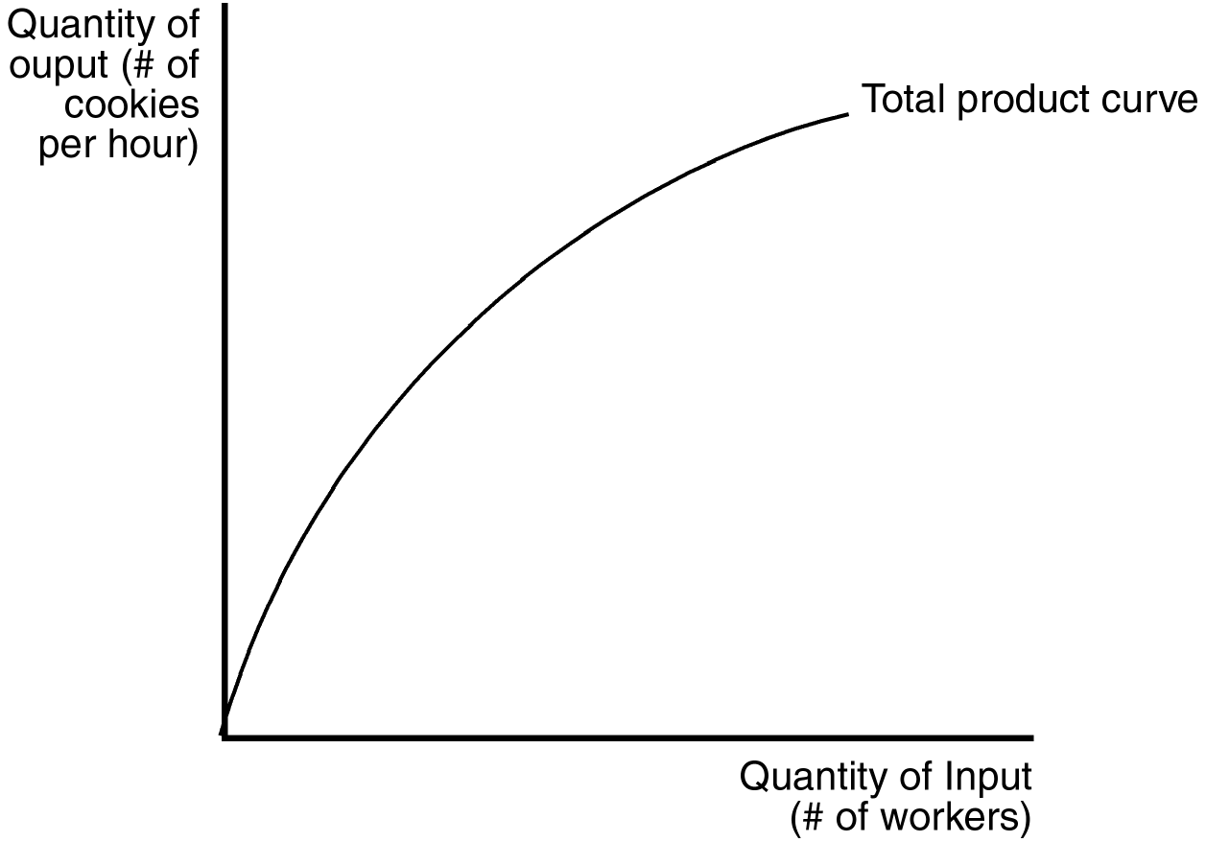

52. As the number of workers increases,
a. total output increases, but at a decreasing rate.
b. marginal product increases, but at a decreasing rate.
c. marginal product increases at an increasing rate.
d. total output decreases.
ANSWER: a. total output increases, but at a decreasing rate.
TYPE: M DIFFICULTY: 2 SECTION: 13.2
53. With regard to cookie production, the figure implies
a. diminishing marginal product of workers.
b. diminishing marginal cost of cookie production.
c. decreasing cost of cookie production.
d. increasing marginal product of workers.
ANSWER: a. diminishing marginal product of workers.
TYPE: M DIFFICULTY: 2 SECTION: 13.2
54. Which of the following statements about a production function is correct for a firm that uses labor to produce output?
a. The production function depicts the relationship between the quantity of labor and the quantity of output.
b. The slope of the production function measures marginal cost.
c. The quantity of output is measured along the horizontal axis.
d. All of the above are correct.
ANSWER: a. The production function depicts the relationship between the quantity of labor and the quantity of output.
TYPE: M DIFFICULTY: 2 SECTION: 13.2

The figure below depicts a total cost function for a firm that produces cookies. Use the figure to answer questions 55 through 58.

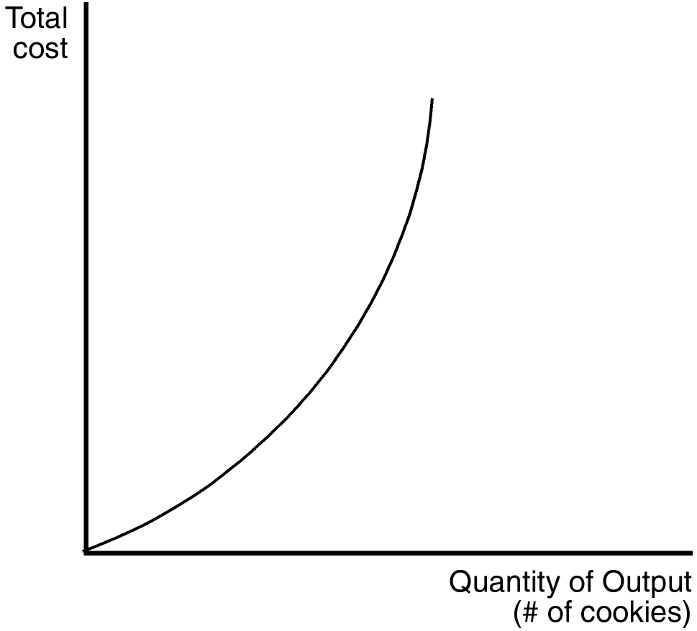

55. Which of the following is true of the production function (not pictured) that underlies this total cost function?
(ii) Total output increases as the quantity of inputs increases, but at a decreasing rate.
(ii) Marginal product is diminishing for all levels of input usage.
(iii) The slope of the production function decreases as the quantity of inputs increases.
a. (i) only
b. (ii) and (iii)
c. (i) and (iii)
d. All of the above are correct.
ANSWER: d. All of the above are correct.
TYPE: M DIFFICULTY: 3 SECTION: 13.2
56. The changing slope of the total cost curve reflects
a. decreasing average variable cost.
b. decreasing average total cost.
c. decreasing marginal product.
d. increasing fixed cost.
ANSWER: c. decreasing marginal product.
TYPE: M DIFFICULTY: 2 SECTION: 13.2
57. Which of the following statements best captures the nature of the underlying production function?
a. Output increases at a decreasing rate with additional units of input.
b. Output increases at an increasing rate with additional units of input.
c. Output decreases at a decreasing rate with additional units of input.
d. Output decreases at an increasing rate with additional units of input.
ANSWER: a. Output increases at a decreasing rate with additional units of input.
TYPE: M DIFFICULTY: 2 SECTION: 13.2
58. Which of the statements below is most consistent with the shape of the total cost curve?
a. Producing an additional cookie is always more costly than producing the previous cookie.
b. Total production of cookies decreases with additional units of input.
c. Producing additional cookies is equally costly, regardless of how many cookies are already being produced.
d. Producing additional cookies becomes increasingly costly only when the number of cookies already being produced is large.
ANSWER: a. Producing an additional cookie is always more costly than producing the previous cookie.
TYPE: M DIFFICULTY: 2 SECTION: 13.2
59. Which of these assumptions is often realistic for a firm in the short run?
a. The firm can vary both the size of its factory and the number of workers it employs.
b. The firm can vary the size of its factory, but not the number of workers it employs.
c. The firm can vary the number of workers it employs, but not the size of its factory.
d. The firm can vary neither the size of its factory nor the number of workers it employs.
ANSWER: c. The firm can vary the number of workers it employs, but not the size of its factory.
TYPE: M DIFFICULTY: 1 SECTION: 13.2
60. Assume a certain firm regards the number of workers it employs as variable, and that it regards the size of its factory as fixed. This assumption is often realistic
a. in the short run, but not in the long run.
b. in the long run, but not in the short run.
c. both in the short run and in the long run.
d. neither in the short run nor in the long run.
ANSWER: a. in the short run, but not in the long run.
TYPE: M DIFFICULTY: 1 SECTION: 13.2
61. For a firm, the production function represents the relationship between
a. implicit costs and explicit costs.
b. quantity of inputs and total cost.
c. quantity of inputs and quantity of output.
d. quantity of output and total cost.
ANSWER: c. quantity of inputs and quantity of output.
TYPE: M DIFFICULTY: 1 SECTION: 13.2
62. For a firm, the relationship between the quantity of inputs and quantity of output is called the
a. profit function.
b. production function.
c. total-cost function.
d. quantity function.
ANSWER: b. production function.
TYPE: M DIFFICULTY: 1 SECTION: 13.2
63. For a certain firm, the number of workers hired is the only variable input. When this firm’s production function is illustrated on a graph,
a. the number of workers is measured on the horizontal axis and the quantity of output is measured on the vertical axis.
b. the number of workers is measured on the horizontal axis and variable cost is measured on the vertical axis.
c. the number of workers is measured on the horizontal axis and profit is measured on the vertical axis.
d. total cost is measured on the horizontal axis and the number of workers is measured on the vertical axis.
ANSWER: a. the number of workers is measured on the horizontal axis and the quantity of output is measured on the vertical axis.
TYPE: M DIFFICULTY: 1 SECTION: 13.2
64. The marginal product of an input in the production process is the increase in
a. total revenue obtained from an additional unit of that input.
b. profit obtained from an additional unit of that input.
c. total revenue obtained from an additional unit of that input.
d. quantity of output obtained from an additional unit of that input.
ANSWER: d. quantity of output obtained from an additional unit of that input.
TYPE: M DIFFICULTY: 1 SECTION: 13.2
65. When a firm’s only variable input is labor, then the slope of the production function measures the
a. quantity of labor.
b. quantity of output.
c. total cost.
d. marginal product of labor.
ANSWER: d. marginal product of labor.
TYPE: M DIFFICULTY: 1 SECTION: 13.2
66. Let L represent the number of workers hired by a firm and let Q represent that firm’s quantity of output. Assume two points on the firm’s production function are (L = 12, Q = 122) and (L = 13, Q = 130). Then the marginal product of the 13th worker is
a. 8 units of output.
b. 10 units of output.
c. 122 units of output.
d. 130 units of output.
ANSWER: a. 8 units of output.
TYPE: M DIFFICULTY: 2 SECTION: 13.2
67. On a 100-acre farm, a farmer is able to produce 3,000 bushels of wheat when he hires 2 workers. He is able to produce 4,400 bushels of wheat when he hires 3 workers. Which of the following possibilities is consistent with the property of diminishing marginal product?
a. The farmer is able to produce 5,600 bushels of wheat when he hires 4 workers.
b. The farmer is able to produce 5,800 bushels of wheat when he hires 4 workers.
c. The farmer is able to produce 6,000 bushels of wheat when he hires 4 workers.
d. All of the above are correct.
ANSWER: a. The farmer is able to produce 5,600 bushels of wheat when he hires 4 workers.
TYPE: M DIFFICULTY: 2 SECTION: 13.2
68. Suppose a certain firm is able to produce 160 units of output per day when 15 workers are hired. The firm is able to produce 176 units of output per day when 16 workers are hired (holding other inputs fixed). Then the marginal product of the 16th worker is
a. 10 units of output.
b. 11 units of output.
c. 16 units of output.
d. 176 units of output.
ANSWER: c. 16 units of output.
TYPE: M DIFFICULTY: 1 SECTION: 13.2
69. A total-cost curve shows the relationship between the
a. quantity of an input used and the total cost of production.
b. quantity of output produced and the total cost of production.
c. total cost of production and profit.
d. total cost of production and total revenue.
ANSWER: b. the quantity of output produced and the total cost of production.
TYPE: M DIFFICULTY: 1 SECTION: 13.2
70. Which of the following costs do not vary with the amount of output a firm produces?
a. average fixed costs
b. fixed costs and average fixed costs
c. marginal costs and average fixed costs
d. fixed costs
ANSWER: d. fixed costs
TYPE: M DIFFICULTY: 1 SECTION: 13.3
71. An example of a fixed cost would be
(i) raw materials supplied at a government -regulated price.
(ii) rent paid on a factory.
(iii) machine maintenance.
a. (ii) only
b. (i) and (ii)
c. (ii) and (iii)
d. All of the above are correct.
ANSWER: b. (i) and (ii)
TYPE: M DIFFICULTY: 2 SECTION: 13.3
72. Fixed costs can be defined as costs that
a. vary inversely with production.
b. vary in proportion with production.
c. are incurred only when production is large enough.
d. are incurred even if nothing is produced.
ANSWER: d. are incurred even if nothing is produced.
TYPE: M DIFFICULTY: 1 SECTION: 13.3
73. Suppose Jan is starting up a small lemonade stand business. Variable costs for Jan’s lemonade stand would include the cost of
a. building the lemonade stand.
b. hiring an artist to design a logo for her sign.
c. lemonade mix.
d. All of the above are correct.
ANSWER: c. lemonade mix.
TYPE: M DIFFICULTY: 2 SECTION: 13.3
74. If a firm produces nothing, which of the following costs will be zero?
a. total cost
b. fixed cost
c. opportunity cost
d. variable cost
ANSWER: d. variable cost
TYPE: M DIFFICULTY: 1 SECTION: 13.3
75. One assumption that distinguishes short-run cost analysis from long-run cost analysis for a profit-maximizing firm is that in the short run,
a. output is not variable.
b. the number of workers used to produce the firm's product is fixed.
c. the size of the factory is fixed.
d. there are no fixed costs.
ANSWER: c. the size of the factory is fixed.
TYPE: M DIFFICULTY: 2 SECTION: 13.3
76. The cost of producing the typical unit of output is the firm’s
a. average total cost.
b. opportunity cost.
c. variable cost.
d. marginal cost.
ANSWER: a. average total cost.
TYPE: M DIFFICULTY: 2 SECTION: 13.3
77. Average total cost is equal to
a. output/total cost.
b. total cost – total quantity of output.
c. average variable cost + total fixed cost.
d. total cost/output.
ANSWER: d. total cost/output.
TYPE: M DIFFICULTY: 1 SECTION: 13.3
78. The amount by which total cost rises when the firm produces one additional unit of output is called
a. average cost.
b. marginal cost.
c. fixed cost.
d. variable cost.
ANSWER: b. marginal cost.
TYPE: M DIFFICULTY: 1 SECTION: 13.3
79. The cost of producing an additional unit of output is the firm’s
a. marginal cost.
b. productivity offset.
c. variable cost.
d. average variable cost.
ANSWER: a. marginal cost.
TYPE: M DIFFICULTY: 1 SECTION: 13.3
80. Average total cost equals
a. change in total costs divided by quantity produced.
b. change in total costs divided by change in quantity produced.
c. (fixed costs + variable costs) divided by quantity produced.
d. (fixed costs + variable costs) divided by change in quantity produced.
ANSWER: c. (fixed costs + variable costs) divided by quantity produced.
TYPE: M DIFFICULTY: 2 SECTION: 13.3
81. Variable cost divided by quantity produced is
a. average total cost.
b. marginal cost.
c. profit.
d. None of the above are correct.
ANSWER: d. None of the above are correct.
TYPE: M DIFFICULTY: 2 SECTION: 13.3
82. Marginal cost equals
(i) change in total cost divided by change in quantity produced.
(ii) change in variable cost divided by change in quantity produced.
(iii) the average fixed cost of the current unit.
a. (i) and (ii)
b. (ii) and (iii)
c. (ii) only
d. All of the above are correct.
ANSWER: a. (i) and (ii)
TYPE: M DIFFICULTY: 2 SECTION: 13.3
83. Variable cost divided by change in quantity produced is
a. average variable cost.
b. marginal cost.
c. average total cost.
d. None of the above are correct.
ANSWER: d. None of the above are correct.
TYPE: M DIFFICULTY: 2 SECTION: 13.3
84. Marginal cost equals
a. total cost divided by quantity of output produced.
b. total output divided by the change in total cost.
c. the slope of the total cost curve.
d. None of the above are correct.
ANSWER: c. the slope of the total cost curve.
TYPE: M DIFFICULTY: 2 SECTION: 13.3
85. Average total cost tells us the
a. total cost of the first unit of output, if total cost is divided evenly over all the units produced.
b. cost of a typical unit of output, if total cost is divided evenly over all the units produced.
c. cost of the last unit of output, if total cost does not include a fixed cost component.
d. variable cost of a firm that is producing at least one unit of output.
ANSWER: b. cost of a typical unit of output, if total cost is divided evenly over all the units produced.
TYPE: M DIFFICULTY: 2 SECTION: 13.3
86. Marginal cost tells us the
a. value of all resources used in a production process.
b. marginal increment to profitability when price is constant.
c. amount by which total cost rises when output is increased by one unit.
d. amount by which output rises when labor is increased by one unit.
ANSWER: c. amount by which total cost rises when output is increased by one unit.
TYPE: M DIFFICULTY: 2 SECTION: 13.3

For questions 87 through 90, assume that a given firm experiences decreasing marginal product of labor with the addition of each worker regardless of the current output level.
87. Average total cost will be
a. always rising.
b. always falling.
c. constant.
d. U-shaped.
ANSWER: d. U-shaped.
TYPE: M DIFFICULTY: 2 SECTION: 13.3
88. Average fixed cost will be
a. always rising.
b. always falling.
c. U-shaped.
d. constant.
ANSWER: b. always falling.
TYPE: M DIFFICULTY: 2 SECTION: 13.3
89. Average variable cost will be
a. always rising.
b. always falling.
c. U-shaped.
d. constant.
ANSWER: a. always rising.
TYPE: M DIFFICULTY: 2 SECTION: 13.3
90. Marginal cost will be
a. always rising.
b. always falling.
c. U-shaped.
d. constant.
ANSWER: a. always rising.
TYPE: M DIFFICULTY: 2 SECTION: 13.3

Use the figure below to answer question 91.

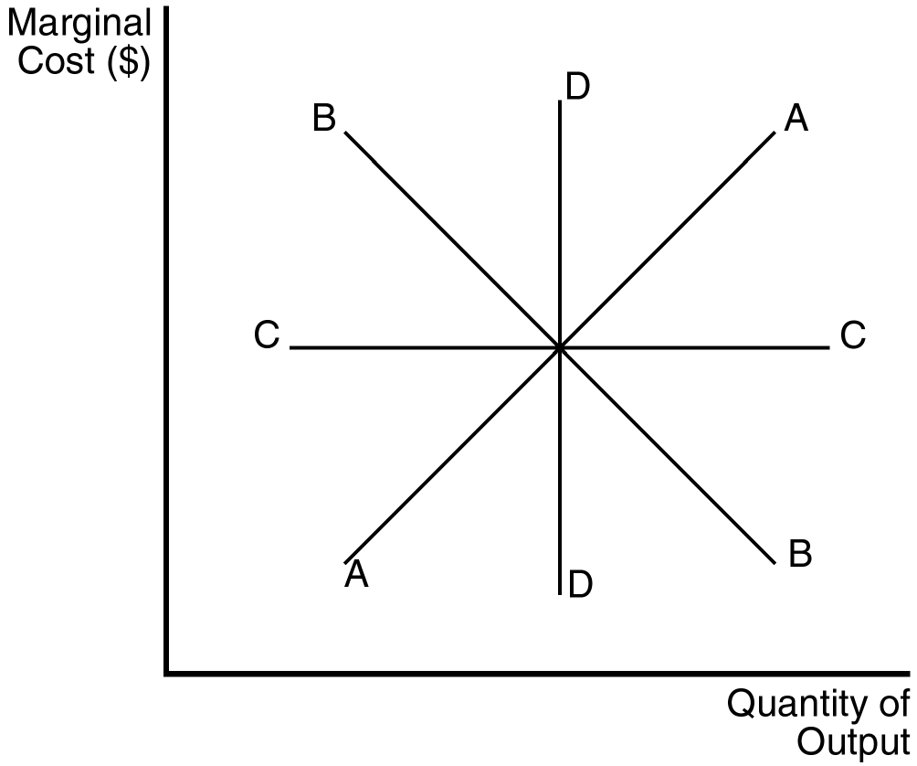

91. Which of the above marginal cost curves reflects the existence of diminishing marginal product?
a. A
b. B
c. C
d. D
ANSWER: a. A
TYPE: M DIFFICULTY: 2 SECTION: 13.3
92. If marginal cost is rising,
a. average variable cost must be falling.
b. average fixed cost must be rising.
c. marginal product must be falling.
d. marginal product must be rising.
ANSWER: c. marginal product must be falling.
TYPE: M DIFFICULTY: 2 SECTION: 13.3
93. Diminishing marginal product suggests that the marginal
a. cost of an extra worker is unchanged.
b. cost of an extra worker is less than the previous worker’s marginal cost.
c. product of an extra worker is less than the previous worker’s marginal product.
d. product of an extra worker is greater than the previous worker’s marginal product.
ANSWER: c. product of an extra worker is less than the previous worker’s marginal product.
TYPE: M DIFFICULTY: 2 SECTION: 13.3
94. Diminishing marginal product suggests that
a. additional units of output become less costly as more output is produced.
b. marginal cost is upward sloping.
c. the firm is at full capacity.
d. All of the above are correct.
ANSWER: b. marginal cost is upward sloping.
TYPE: M DIFFICULTY: 2 SECTION: 13.3
95. The average fixed cost curve
a. always declines with increased levels of output.
b. always rises with increased levels of output.
c. declines as long as it is above marginal cost.
d. declines as long as it is below marginal cost.
ANSWER: a. always declines with increased levels of output.
TYPE: M DIFFICULTY: 2 SECTION: 13.3
96. Average total cost is very high when a small amount of output is produced because
a. average variable cost is high.
b. average fixed cost is high.
c. marginal cost is high.
d. All of the above are correct.
ANSWER: b. average fixed cost is high.
TYPE: M DIFFICULTY: 2 SECTION: 13.3
97. Total cost necessarily rises due to
(i) rising marginal cost.
(ii) falling marginal cost.
(iii) increasing marginal product.
a. (i) only
b. (i) and (ii)
c. (ii) only
d. None of the above are correct.
ANSWER: d. None of the above are correct.
TYPE: M DIFFICULTY: 2 SECTION: 13.3
98. The efficient scale of the firm is the quantity of output that
a. maximizes marginal product.
b. maximizes profit.
c. minimizes average total cost.
d. minimizes average variable cost.
ANSWER: c. minimizes average total cost.
TYPE: M DIFFICULTY: 1 SECTION: 13.3
99. When marginal cost is less than average total cost,
a. marginal cost must be falling.
b. average variable cost must be falling.
c. average total cost is falling.
d. average total cost is rising.
ANSWER: c. average total cost is falling.
TYPE: M DIFFICULTY: 2 SECTION: 13.3
100. When marginal cost exceeds average total cost,
a. average fixed cost must be rising.
b. average total cost must be rising.
c. average total cost must be falling.
d. marginal cost must be falling.
ANSWER: b. average total cost must be rising.
TYPE: M DIFFICULTY: 2 SECTION: 13.3
101. Average total cost is increasing whenever
a. total cost is increasing.
b. marginal cost is increasing.
c. marginal cost is less than average total cost.
d. marginal cost is greater than average total cost.
ANSWER: d. marginal cost is greater than average total cost.
TYPE: M DIFFICULTY: 2 SECTION: 13.3
102. Johnny is a sophomore in college and has a 1.5 cumulative grade point average (GPA). Johnny’s cumulative GPA will fall even further next semester if he performs worse than
(i) his cumulative GPA.
(ii) he ever performed before.
(iii) he did last semester.
a. (i) and (ii)
b. (i) and (iii)
c. (ii) and (iii)
d. All of the above are correct.
ANSWER: a. (i) and (ii)
TYPE: M DIFFICULTY: 3 SECTION: 13.3
103. Johnny is a sophomore in college and has a 1.5 cumulative grade point average (GPA). Johnny’s cumulative GPA will be better next semester if he
(i) performs better than he did last semester.
(ii) performs better than his cumulative GPA.
(iii) gives an average performance.
a. (ii) only
b. (iii) only
c. (i) and (iii)
d. All of the above are correct.
ANSWER: a. (ii) only
TYPE: M DIFFICULTY: 3 SECTION: 13.3
104. Marginal cost is equal to average total cost when
a. average variable cost is falling.
b. average fixed cost is rising.
c. marginal cost is at its minimum.
d. average total cost is at its minimum.
ANSWER: d. average total cost is at its minimum.
TYPE: M DIFFICULTY: 2 SECTION: 13.3
105. The marginal cost curve crosses the average total cost curve at
a. the efficient scale.
b. the minimum point on the average total cost curve.
c. a point where the marginal cost curve is rising.
d. All of the above are correct.
ANSWER: d. All of the above are correct.
TYPE: M DIFFICULTY: 2 SECTION: 13.3
106. If marginal cost is below average total cost, then average total cost
a. is constant.
b. is falling.
c. is rising.
d. may rise or fall depending on the size of fixed costs.
ANSWER: b. is falling.
TYPE: M DIFFICULTY: 2 SECTION: 13.3
107. At all levels of production beyond the point where the marginal cost curve crosses the average variable cost curve, average variable cost
a. rises.
b. remains unaffected.
c. falls.
d. All of the above are possible, it depends on the shape of the marginal cost curve.
ANSWER: a. rises.
TYPE: M DIFFICULTY: 2 SECTION: 13.3
Use the figure below to answer question 108.

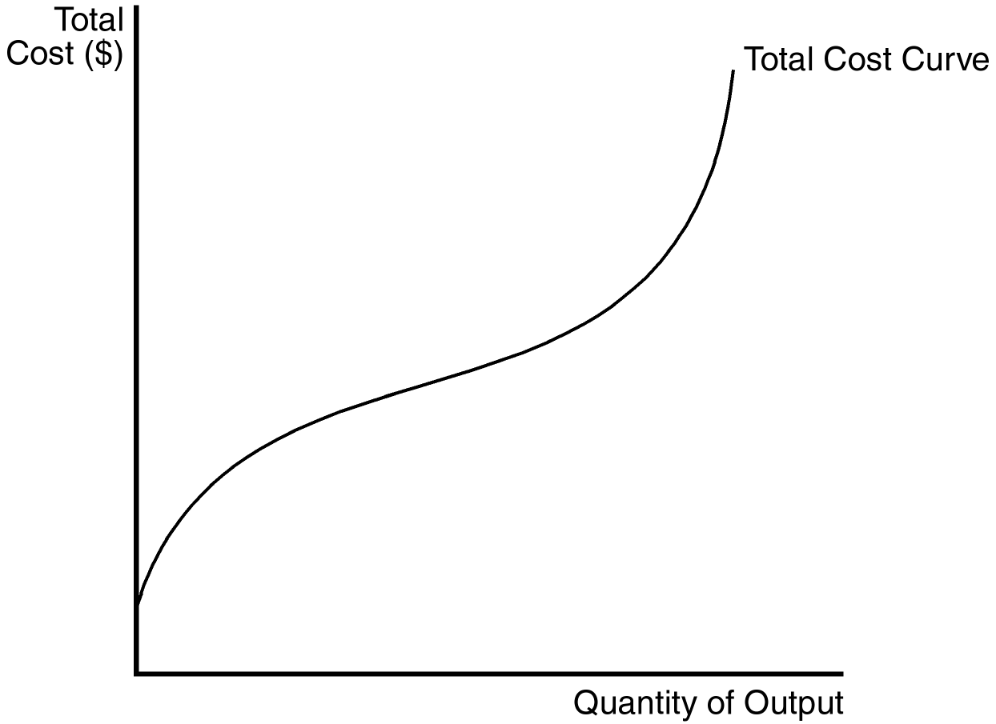

108. Which of the following can be inferred from the figure above?
(i) Marginal cost is increasing at all levels of output.
(ii) Marginal product is increasing at low levels of output.
(iii) Marginal product is decreasing at high levels of output.
a. (i) and (ii)
b. (ii) and (iii)
c. (i) and (iii)
d. All of the above are correct.
ANSWER: b. (ii) and (iii)
TYPE: M DIFFICULTY: 3 SECTION: 13.3

The curves below reflect information about the cost structure of a firm. Use the figure to answer questions 109 through 115.

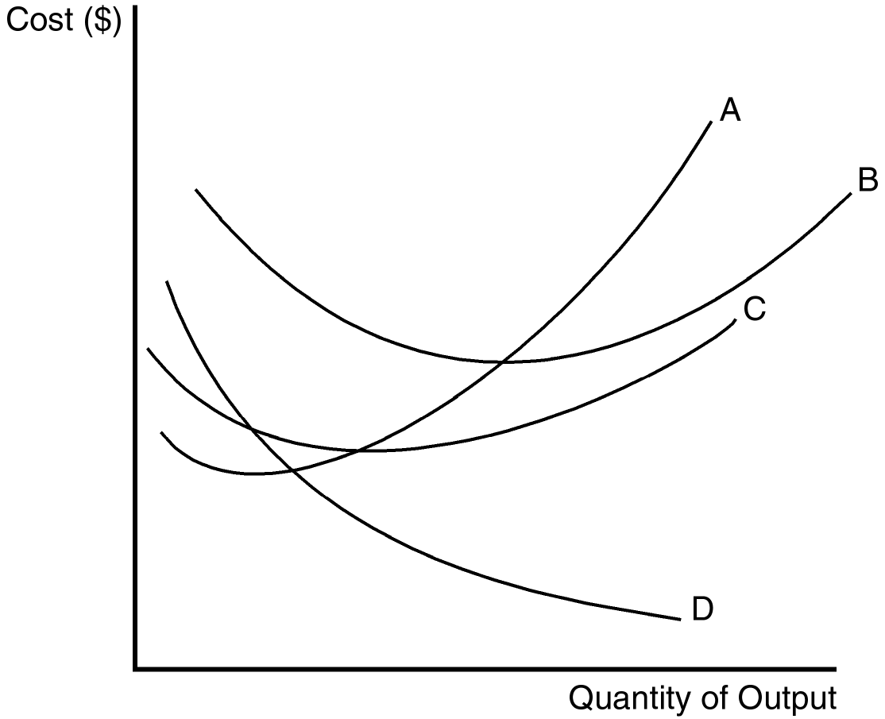

109. Which of the curves is most likely to represent average total cost?
a. A
b. B
c. C
d. D
ANSWER: b. B
TYPE: M DIFFICULTY: 2 SECTION: 13.3
110. Which of the curves is most likely to represent average fixed cost?
a. A
b. B
c. C
d. D
ANSWER: d. D
TYPE: M DIFFICULTY: 2 SECTION: 13.3
111. Which of the curves is most likely to represent average variable cost?
a. A
b. B
c. C
d. D
ANSWER: c. C
TYPE: M DIFFICULTY: 2 SECTION: 13.3
112. Which of the curves is most likely to represent marginal cost?
a. A
b. B
c. C
d. D
ANSWER: a. A
TYPE: M DIFFICULTY: 2 SECTION: 13.3
113. This particular firm is necessarily experiencing increasing marginal product when curve
a. A is falling.
b. B is falling.
c. C is falling.
d. D is falling.
ANSWER: a. A is falling.
TYPE: M DIFFICULTY: 3 SECTION: 13.3
114. This particular firm is necessarily experiencing diminishing marginal product when curve
(i) A is rising.
(ii) B is rising.
(iii) C is rising.
a. (i) only
b. (iii) only
c. (i) and (ii)
d. All of the above are correct.
ANSWER: d. All of the above are correct.
TYPE: M DIFFICULTY: 3 SECTION: 13.3
115. Curve A is U-shaped because of
a. diminishing marginal product.
b. increasing marginal product.
c. the fact that increasing marginal product follows decreasing marginal product.
d. the fact that decreasing marginal product follows increasing marginal product.
ANSWER: d. the fact that decreasing marginal product follows increasing marginal product.
TYPE: M DIFFICULTY: 3 SECTION: 13.3
116. Total cost can be divided into two types. Those two types are
a. fixed costs and variable costs.
b. fixed costs and marginal costs.
c. variable costs and marginal costs.
d. average costs and marginal costs.
ANSWER: a. fixed costs and variable costs.
TYPE: M DIFFICULTY: 1 SECTION: 13.3
117. Some costs do not vary with the quantity of output produced. Those costs are called
a. marginal costs.
b. average costs.
c. fixed costs.
d. incurred costs.
ANSWER: c. fixed costs.
TYPE: M DIFFICULTY: 1 SECTION: 13.3
118. For a construction company that builds houses, which of the following costs would be a fixed cost?
a. the $50,000 per year salary paid to a construction foreman
b. the $30,000 per year salary paid to the company’s bookkeeper
c. the $10,000 per year premium paid to an insurance company
d. All of the above are correct.
ANSWER: d. All of the above are correct.
TYPE: M DIFFICULTY: 1 SECTION: 13.3
119. For a large firm that produces and sells automobiles, which of the following costs would be a variable cost?
a. the $20 million payment that the firm pays each year for accounting services
b. the cost of the steel that is used in producing automobiles
c. the rent that the firm pays for office space in a suburb of St. Louis
d. All of the above are correct.
ANSWER: b. the cost of the steel that is used in producing automobiles
TYPE: M DIFFICULTY: 2 SECTION: 13.3
120. Which of the following expressions is correct?
a. marginal cost = (change in quantity of output)/(change in total cost).
b. average total cost = total cost/quantity of output.
c. total cost = variable cost + marginal cost.
d. All of the above are correct.
ANSWER: b. average total cost = total cost/quantity of output.
TYPE: M DIFFICULTY: 2 SECTION: 13.3
121. Average total cost (ATC) is calculated as follows:
a. ATC = (change in total cost)/(change in quantity of output).
b. ATC = (change in total cost)/(change in quantity of input).
c. ATC = total cost/quantity of output.
d. ATC = total cost/quantity of input.
ANSWER: c. ATC = total cost/quantity of output.
TYPE: M DIFFICULTY: 1 SECTION: 13.3
122. Implicit costs
a. do not require an outlay of money by the firm.
b. do not enter into the economist’s measurement of a firm’s profit.
c. are also known as variable costs.
d. All of the above are correct.
ANSWER: a. do not require an outlay of money by the firm.
TYPE: M DIFFICULTY: 2 SECTION: 13.3
123. Which of the following measures of cost is best described as “the increase in total cost that arises from an extra unit of production?”
a. variable cost
b. average variable cost
c. average total cost
d. marginal cost
ANSWER: d. marginal cost
TYPE: M DIFFICULTY: 1 SECTION: 13.3
124. Which of the following measures of cost is best described as “the cost of a typical unit of output if total cost is divided evenly over all the units produced?”
a. average fixed cost
b. average variable cost
c. average total cost
d. marginal cost
ANSWER: c. average total cost
TYPE: M DIFFICULTY: 1 SECTION: 13.3
125. Marginal cost increases as the quantity of output increases. This reflects the property of
a. increasing total cost.
b. diminishing total cost.
c. increasing marginal product.
d. diminishing marginal product.
ANSWER: d. diminishing marginal product.
TYPE: M DIFFICULTY: 2 SECTION: 13.3
126. In the short run, a firm incurs fixed costs
a. only if it incurs variable costs.
b. only if it produces no output.
c. only if it produces a positive quantity of output.
d. if it produces no output or if it produces a positive quantity of output.
ANSWER: d. if it produces no output or if it produces a positive quantity of output.
TYPE: M DIFFICULTY: 1 SECTION: 13.3

Refer to the following information to answer Questions 127 through 131.

A certain firm produces and sells staplers. Last year, it produced 5,000 staplers and sold each stapler for $8. In producing the 5,000 staplers, it incurred variable costs of $30,000 and a total cost of $45,000.
127. The firm’s fixed costs amounted to
a. $15,000.
b. $30,000.
c. $40,000.
d. $50,000.
ANSWER: a. $15,000.
TYPE: M DIFFICULTY: 1 SECTION: 13.3
128. In producing the 5,000 staplers, the firm’s average fixed cost was
a. $3.
b. $4.
c. $5.
d. $7.
ANSWER: a. $3.
TYPE: M DIFFICULTY: 2 SECTION: 13.3
129. In producing the 5,000 staplers, the firm’s average variable cost was
a. $2.
b. $4.
c. $6.
d. $8.
ANSWER: c. $6.
TYPE: M DIFFICULTY: 1 SECTION: 13.3
130. In producing the 5,000 staplers, the firm’s average total cost was
a. $6.
b. $7.
c. $8.
d. $9.
ANSWER: d. $9.
TYPE: M DIFFICULTY: 1 SECTION: 13.3
131. The firm’s economic profit for the year was
a. $–35,000.
b. $–5,000
c. $10,000.
d. $40,000.
ANSWER: b. $–5,000
TYPE: M DIFFICULTY: 2 SECTION: 13.3

Refer to the figures below to answer Questions 132 through 134

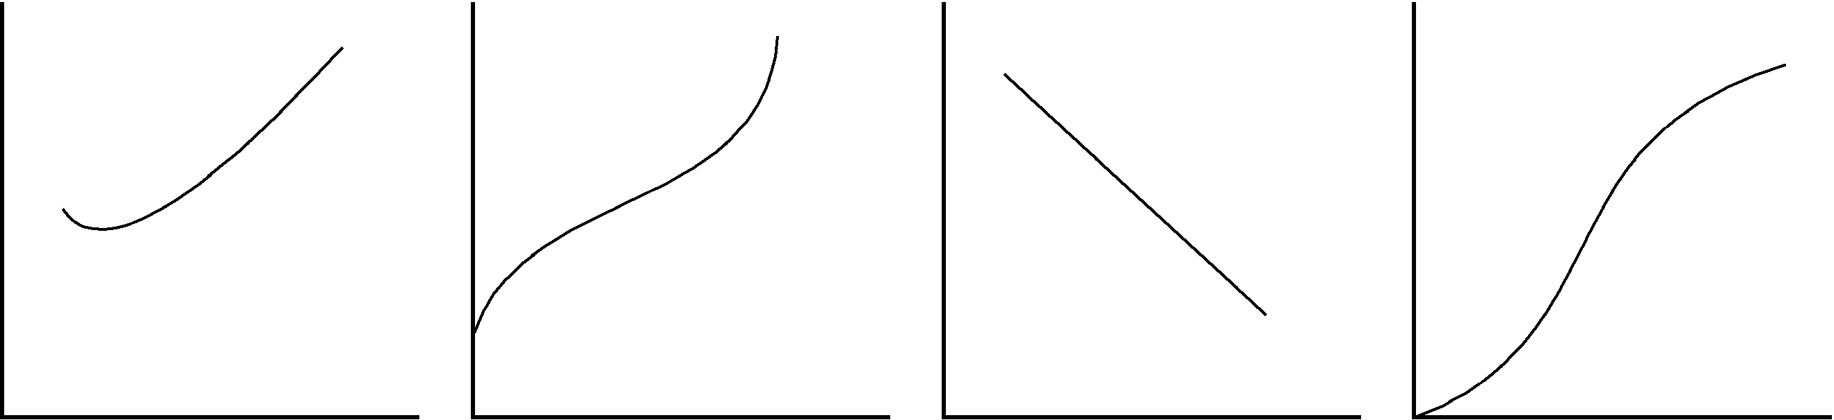
Figure 1 Figure 2 Figure 3 Figure 4
132. Which of the figures represents the total cost curve for a firm?
a. Figure 1
b. Figure 2
c. Figure 3
d. Figure 4
ANSWER: b. Figure 2
TYPE: M DIFFICULTY: 1 SECTION: 13.3
133. Which of the figures represents the marginal cost curve for a firm?
a. Figure 1
b. Figure 2
c. Figure 3
d. Figure 4
ANSWER: a. Figure 1
TYPE: M DIFFICULTY: 1 SECTION: 13.3
134. Which of the figures represents the production function for a firm?
a. Figure 1
b. Figure 2
c. Figure 3
d. Figure 4
ANSWER: D TYPE: M DIFFICULTY: 1 SECTION: 13.3
135. Which of the following statements about costs is correct?
a. When marginal cost is less than average total cost, average total cost is rising.
b. The total cost curve is U-shaped.
c. As the quantity of output increases, marginal cost eventually rises.
d. All of the above are correct.
ANSWER: c. As the quantity of output increases, marginal cost eventually rises.
TYPE: M DIFFICULTY: 2 SECTION: 13.3
136. Whenever marginal cost is greater than average total cost,
a. marginal cost is rising.
b. marginal cost is falling.
c. average total cost is rising.
d. average total cost is falling.
ANSWER: c. average total cost is rising.
TYPE: M DIFFICULTY: 2 SECTION: 13.3
137. The firm’s efficient scale is the quantity of output that minimizes
a. average total cost.
b. average fixed cost.
c. average variable cost.
d. marginal cost.
ANSWER: a. average total cost.
TYPE: M DIFFICULTY: 1 SECTION: 13.3

Use the following information to answer questions 138 through 144.

Measures of Cost for ABC Inc. Widget Factory

Quantity Variable Total Fixed
of Widgets Costs Costs Costs
0 $10
1 $1
2 $3 $13
3 $6 $16
4 $10
5 $25
6 $21 $10
138. The average fixed cost of producing five widgets is
a. $1.00.
b. $2.00.
c. $3.00.
d. None of the above are correct.
ANSWER: b. $2.00.
TYPE: M DIFFICULTY: 2 SECTION: 13.3
139. The average variable cost of producing four widgets is
a. $2.00
b. $2.50
c. $3.33
d. $5.00
ANSWER: b. $2.50
TYPE: M DIFFICULTY: 2 SECTION: 13.3
140. The average total cost of producing one widget is
a. $1.00.
b. $10.00.
c. $11.00.
d. $22.00.
ANSWER: c. $11.00.
TYPE: M DIFFICULTY: 2 SECTION: 13.3
141. The marginal cost of producing the sixth widget is
a. $1.00.
b. $3.50.
c. $5.00.
d. $6.00.
ANSWER: d. $6.00.
TYPE: M DIFFICULTY: 2 SECTION: 13.3
142. What is the variable cost of producing zero widgets?
a. $0
b. $1.00
c. $10.00
d. $10.00
ANSWER: a. $0
TYPE: M DIFFICULTY: 2 SECTION: 13.3
143. What is the marginal cost of producing the first widget?
a. $1.00
b. $10.00
c. $11.00
d. It can't be determined from the information given.
ANSWER: a. $1.00
TYPE: M DIFFICULTY: 2 SECTION: 13.3
144. What is the variable cost of producing five widgets?
a. $13.00
b. $14.00
c. $15.00
d. It can't be determined from the information given.
ANSWER: c. $15.00
TYPE: M DIFFICULTY: 2 SECTION: 13.3

Use the following information to answer questions 145 through 149.

Adrian's Premium Boxing Service subcontracts with a chocolate manufacturer to box premium chocolates for their mail order catalogue business. She rents a small room for $150 a week in the downtown business district that serves as her factory. She can hire workers for $275 a week.
Number of Workers | Chocolates Produced per Week | Marginal Product of Labor | Cost of Factory | Cost of Workers | Total Cost of Inputs
0 | 0
1 |  | 330 | 150 | 275 | 425
2 | 630
3 |  | 150 |  | 825 | 975
4 | 890
5 | 950 | 60 |  | 1,375
6 |  | 10 |  |  | 1,800

145. What is the marginal product of the second worker?
a. 110
b. 200
c. 260
d. 300
ANSWER: d. 300
TYPE: M DIFFICULTY: 2 SECTION: 13.3
146. What is the total cost associated with making 890 boxes of premium chocolates per week?
a. 1,250
b. 1,325
c. 1,400
d. 1,575
ANSWER: a. 1,250
TYPE: M DIFFICULTY: 2 SECTION: 13.3
147. During the week of July 4th, Adrian doesn't box any chocolates. What are her costs during the week?
a. 0
b. 150
c. 275
d. 425
ANSWER: b. 150
TYPE: M DIFFICULTY: 2 SECTION: 13.3
148. One week, Adrian earns a profit of $125. If her revenue for the week is $1100, how many boxes of chocolate did she produce?
a. 140
b. 330
c. 780
d. 950
ANSWER: c. 780
TYPE: M DIFFICULTY: 2 SECTION: 13.3
149. Adrian has received an order for 3000 boxes of chocolates for next week. If she expects that the trend in the marginal product of labor will continue in the same direction, it is most likely that her best decision will be to
a. not commit to meeting the order until she can move to a larger room and hire more workers to box the chocolates.
b. close her business until she is able to hire more productive workers.
c. hire about 12 new workers and hope she can satisfy the order.
d. commit to meeting the order and then take three weeks to complete the job.
ANSWER: a. not commit to meeting the order until she can move to a larger room and hire more workers to box the chocolates.
TYPE: M DIFFICULTY: 2 SECTION: 13.3

Use the following information to answer questions 150 through 154.

Teacher’s Helper is a small company that has a subcontract to produce instructional materials for disabled children in public school districts. The owner rents several small rooms in an office building in the suburbs for $600 a month and has leased computer equipment that costs $480 a month.

Output (Instructional Modules per Month) | Fixed Costs | Variable Costs | Total Cost | Average Fixed Cost | Average Variable Cost | Average Total Cost | Marginal Cost
0 | 1,080
1 | 1,080 | 400 | 1,480 |  |  |  | 400
2 |  |  |  |  |  | 965 | 450
3 |  | 1,350 | 2,430
4 |  | 1,900 |  |  | 475
5 |  | 2,500 |  | 216
6 |  |  | 4,280 |  |  |  | 700
7 |  | 4,100
8 |  | 5,400 |  | 135
9 |  | 7,300
10 |  |  | 10,880 |  | 980

150. What is the marginal cost of creating the tenth instructional module in a given month?
a. $900
b. $1,250
c. $2,500
d. $3,060
ANSWER: c. $2,500
TYPE: M DIFFICULTY: 2 SECTION: 13.3
151. What is the average variable cost for the month if six instructional modules are produced?
a. $180
b. $533.33
c. $700
d. $713.33
ANSWER: b. $533.33
TYPE: M DIFFICULTY: 2 SECTION: 13.3
152. What is the average fixed cost for the month if nine instructional modules are produced?
a. $108
b. $120
c. $150
d. $811.11
ANSWER: b. $120
TYPE: M DIFFICULTY: 2 SECTION: 13.3
153. How many instructional modules are produced when marginal cost is $1,300?
a. 4
b. 5
c. 7
d. 8
ANSWER: d. 8
TYPE: M DIFFICULTY: 2 SECTION: 13.3
154. One month, Teacher's Helper produced 18 instructional modules. What was the average fixed cost for that month?
a. 60
b. 108
c. 811
d. It can't be determined from the information given.
ANSWER: a. 60
TYPE: M DIFFICULTY: 2 SECTION: 13.3
155. At what level of output will average variable cost equal average total cost?
a. when marginal cost equals average total cost
b. for all levels of output in which average variable cost is falling
c. when marginal cost equals average variable cost
d. There is not a level of output where this occurs, as long as fixed costs are positive.
ANSWER: d. There is not a level of output where this occurs, as long as fixed costs are positive.
TYPE: M DIFFICULTY: 2 SECTION: 13.3

Use the following information to answer questions 156 through 158.

Farmer Jack is a watermelon farmer. If Jack plants no seeds on his farm, he gets no harvest. If he plants 1 bag of seeds, he gets 30 watermelons. If he plants 2 bags of seeds, he gets 50 watermelons. If he plants 3 bags of seeds he gets 60 watermelons. A bag of seeds costs $100, and the costs of seeds are his only costs.
156. Which of the following statements is (are) true?
(i) Farmer Jack experiences decreasing marginal product.
(ii) Farmer Jack’s production function is nonlinear.
(iii) Farmer Jack’s total cost curve is linear.
a. (i) only
b. (i) and (ii)
c. (ii) only
d. (i) and (iii)
ANSWER: b. (i) and (ii)
TYPE: M DIFFICULTY: 2 SECTION: 13.3
157. Which of the following statements is(are) true of Jack’s marginal cost?
(i) His marginal cost curve is U-shaped.
(ii) His marginal cost decreases with increased watermelon output.
(iii) His marginal cost reflects diminishing marginal product.
a. (ii) only
b. (iii) only
c. (i) and (iii)
d. All of the above are correct.
ANSWER: b. (iii) only
TYPE: M DIFFICULTY: 2 SECTION: 13.3
158. Jack’s production function will
a. decrease at a decreasing rate.
b. decrease at an increasing rate.
c. increase at a decreasing rate.
d. increase at an increasing rate.
ANSWER: c. increase at a decreasing rate.
TYPE: M DIFFICULTY: 2 SECTION: 13.3
159. Harry's Hotdogs is a small street vendor business owned by Harry Huggins. Harry is trying to get a better understanding of his costs by categorizing them as fixed or variable. Which of the following costs are most likely to be considered fixed costs?
a. the cost of mustard
b. the cost of hotdog buns
c. wages paid to workers that sell hotdogs
d. the cost of bookkeeping services
ANSWER: d. the cost of bookkeeping services
TYPE: M DIFFICULTY: 2 SECTION: 13.3
160. Harry Potter is a small street vendor service who contracts to produce and sell molded plastic souvenirs (key chains, commemorative plastic coins, plastic animals, etc.) at small, county carnivals. As owner of the firm, Harry must decide how much of each product to produce. A key element of this decision is
a. how costs will vary as he changes the level of production.
b. the cost of bookkeeping services.
c. the fixed cost of production.
d. the cost of his selling booth.
ANSWER: a. how costs will vary as he changes the level of production.
TYPE: M DIFFICULTY: 2 SECTION: 13.3
161. Harry's Hotdogs is a small street vendor business owned by Harry Huggins. If Harry makes 15 hotdogs in his first hour of business and incurs a total cost of $16.50, his average total cost per hotdog is
a. $1.10.
b. $6.50.
c. $16.50
d. It is impossible to determine without specific information on variable cost.
ANSWER: a. $1.10.
TYPE: M DIFFICULTY: 2 SECTION: 13.3
162. When a firm is able to put idle equipment to use by hiring another worker,
a. variable costs will rise.
b. variable costs will fall.
c. fixed costs will fall.
d. fixed costs and variable costs will rise.
ANSWER: a. variable costs will rise.
TYPE: M DIFFICULTY: 2 SECTION: 13.3
163. Thirsty Thelma owns and operates a small lemonade stand. When Thelma is producing a small quantity of lemonade she has few workers and her equipment is not being fully utilized. Because she can easily put her idle resources to use,
a. the marginal cost of an extra worker is large.
b. the marginal cost of one more glass of lemonade is small.
c. the marginal product of an extra worker is small.
d. her lemonade stand is likely to be crowded with workers.
ANSWER: b. the marginal cost of one more glass of lemonade is small.
TYPE: M DIFFICULTY: 2 SECTION: 13.3
164. When a firm is operating at an efficient scale,
a. average variable cost is minimized.
b. average fixed cost is minimized.
c. average total cost is minimized.
d. None of the above are correct.
ANSWER: c. average total cost is minimized.
TYPE: M DIFFICULTY: 2 SECTION: 13.3
165. Which of the following must always be true as the quantity of output increases?
a. Marginal cost must rise.
b. Average total cost must rise.
c. Average variable cost must rise.
d. Average fixed cost must fall.
ANSWER: d. Average fixed cost must fall.
TYPE: M DIFFICULTY: 2 SECTION: 13.3
166. Which of the following statements is false?
a. The marginal cost of the fifth unit of output equals the total cost of five units minus the total cost of four units.
b. The total variable cost of seven units equals the average variable cost of seven units times seven.
c. If marginal cost is rising, then average variable cost must be rising.
d. The marginal cost of the fifth unit of output equals the total variable cost of five units minus the total variable cost of four units.
ANSWER: c
TYPE: M DIFFICULTY: 2 SECTION 13.3
167. When marginal cost is rising, average variable cost
a. must be rising.
b. must be falling.
c. must be constant.
d. could be rising or falling.
ANSWER: d. could be rising or falling.
TYPE: M DIFFICULTY: 3 SECTION: 13.3
168. Consider the following information about bread production at Beth’s Bakery:
Worker Marginal Product
1 5
2 7
3 10
4 11
5 8
6 6
7 4

Beth pays all her workers the same wage and labor is her only variable cost. From this information we can conclude that Beth’s marginal cost
a. declines as output increases from 0 to 33, but increases after that.
b. declines as output increases from 0 to 11, but increases after that.
c. increases as output increases from 0 to 11, but declines after that.
d. continually increases as output rises.
ANSWER: a. declines as output increases from 0 to 33, but increases after that.
TYPE: M DIFFICULTY: 3 SECTION: 13.3
169. Consider the following information about baseball production at Bob’s Baseball Factory:
Worker Marginal Product
1 3
2 5
3 8
4 10
5 7
6 4
7 2
Bob pays all his workers the same wage and labor is his only variable cost. From this information we can conclude that Bob’s average variable cost decreases
a. as output rises from 0 to 10, but rises after that.
b. as output rises from 0 to 26, but rises after that.
c. as output rises from 0 to 33, but increases after that.
d. continually as output rises.
ANSWER: c. as output rises from 0 to 33, but increases after that.
TYPE: M DIFFICULTY: 3 SECTION: 13.3
170. At Bert’s Bootery, the total cost of producing twenty pairs of boots is $400. The marginal cost of producing the twenty-first pair of boots is $83. We can conclude that the average
a. variable cost of 21 pairs of boots is $23.
b. total cost of 21 pairs of boots is $23.
c. total cost of 21 pairs of boots is $15.09
d. total cost of 21 pairs of boots cannot be calculated from the information given.
ANSWER: b. total cost of 21 pairs of boots is $23.
TYPE: M DIFFICULTY: 3 SECTION: 13.3
171. One of the most important properties of cost curves is that
a. for most producers , the average total cost curve never crosses the marginal cost curve.
b. the average fixed cost curve must eventually rise.
c. the average total cost curve first rises, then falls with increased output.
d. the marginal cost curve eventually rises with the quantity of output.
ANSWER: d. the marginal cost curve eventually rises with the quantity of output.
TYPE: M DIFFICULTY: 2 SECTION: 13.3
172. When a factory is operating in the short run,
a. it cannot alter variable costs.
b. total cost and variable cost are usually the same.
c. average fixed cost rises as output increases.
d. it cannot adjust the quantity of fixed inputs.
ANSWER: d. it cannot adjust the quantity of fixed inputs.
TYPE: M DIFFICULTY: 2 SECTION: 13.4
173. In the long run,
a. inputs that were fixed in the short run remain fixed.
b. inputs that were fixed in the short run become variable.
c. inputs that were variable in the short run become fixed.
d. variable inputs are rarely used.
ANSWER: b. inputs that were fixed in the short run become variable.
TYPE: M DIFFICULTY: 2 SECTION: 13.4

The figure below depicts average total cost functions for a firm that produces automobiles. Use the figure to answer questions 174 through 178.

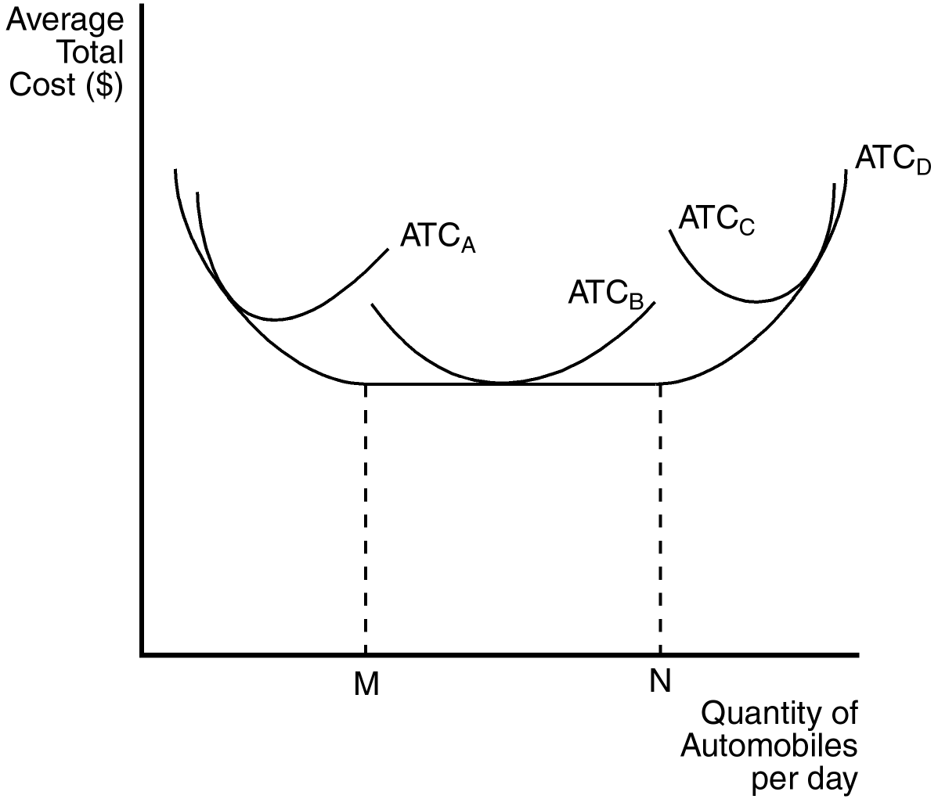

174. Which of the curves is most likely to characterize the short-run average total cost curve of the smallest factory?
a. ATCA
b. ATCB
c. ATCC
d. ATCD
ANSWER: a. ATCA
TYPE: M DIFFICULTY: 1 SECTION: 13.4
175. Which curve represents the long-run average total cost?
a. ATCA
b. ATCB
c. ATCC
d. ATCD
ANSWER: d. ATCD
TYPE: M DIFFICULTY: 1 SECTION: 13.4
176. In the long run, the firm can operate on which of the following average total cost curves?
a. ATCA
b. ATCB
c. ATCC
d. All of the above are correct.
ANSWER: d. All of the above are correct.
TYPE: M DIFFICULTY: 1 SECTION: 13.4
177. This firm experiences diseconomies of scale at what output levels?
a. output levels above N
b. output levels between M and N
c. output levels below M
d. All of the above are correct, if the firm is operating in the long run.
ANSWER: a. output levels above N
TYPE: M DIFFICULTY: 2 SECTION: 13.4
178. At levels of output below M the firm experiences
a. economies of scale.
b. diseconomies of scale.
c. economic profit.
d. accounting profit.
ANSWER: a. economies of scale.
TYPE: M DIFFICULTY: 2 SECTION: 13.4
179. The long-run average total cost curve is always
a. flatter than the short-run average total cost curve, but not necessarily horizontal.
b. horizontal.
c. falling as output increases.
d. rising as output increases.
ANSWER: a. flatter than the short-run average total cost curve, but not necessarily horizontal.
TYPE: M DIFFICULTY: 2 SECTION: 13.4
180. The length of the short run
a. is different for different types of firms.
b. can never exceed 3 years.
c. can never exceed 1 year.
d. is always less than 6 months.
ANSWER: a. is different for different types of firms.
TYPE: M DIFFICULTY: 1 SECTION: 13.4
181. Economies of scale occur when
a. long-run average total costs rise as output increases.
b. long-run average total costs fall as output increases.
c. average fixed costs are falling.
d. average fixed costs are constant.
ANSWER: b. long-run average total costs fall as output increases.
TYPE: M DIFFICULTY: 2 SECTION: 13.4
182. Diseconomies of scale occur when
a. average fixed costs are falling.
b. average fixed costs are constant.
c. long-run average total costs rise as output increases.
d. long-run average total costs fall as output increases.
ANSWER: c. long-run average total costs rise as output increases.
TYPE: M DIFFICULTY: 2 SECTION: 13.4
183. Constant returns to scale occur when
a. long-run total costs are constant as output increases.
b. long-run average total costs are constant as output increases.
c. the firm's long-run average cost curve is falling as output increases.
d. the firm's long-run average cost curve is rising as output increases.
ANSWER: b. long-run average total costs are constant as output increases.
TYPE: M DIFFICULTY: 2 SECTION: 13.4
184. Specialization among workers occurs when
a. quality management allows workers to switch from one task to another.
b. each worker is allowed to perfect one particular task.
c. each worker is responsible for a number of different tasks.
d. All of the above are correct.
ANSWER: b. each worker is allowed to perfect one particular task.
TYPE: M DIFFICULTY: 1 SECTION: 13.4
185. If a firm wants to capitalize on economies of scale, it may be able to do so by
a. assigning limited tasks to their employees, so they can master those tasks.
b. employing a smaller number of workers.
c. producing a smaller quantity of output.
d. All of the above are correct.
ANSWER: a. assigning limited tasks to their employees, so they can master those tasks.
TYPE: M DIFFICULTY: 2 SECTION: 13.4
186. In reference to setting the production level, a firm’s cost curves
a. by themselves do not tell us what decisions the firm will make.
b. dictate what decisions the firm will make.
c. have no bearing on what decisions the firm will make.
d. None of the above are correct.
ANSWER: a. by themselves do not tell us what decisions the firm will make.
TYPE: M DIFFICULTY: 2 SECTION: 13.4
187. Economies of scale arise when
a. an economy is self-sufficient in production.
b. individuals in a society are self-sufficient.
c. fixed costs are large relative to variable costs.
d. workers are able to specialize in a particular task.
ANSWER: d. workers are able to specialize in a particular task.
TYPE: M DIFFICULTY: 2 SECTION: 13.4
188. How long does it take a firm to go from the short run to the long run?
a. six months
b. one year
c. two years
d. It depends on the nature of the firm.
ANSWER: d. It depends on the nature of the firm.
TYPE: M DIFFICULTY: 1 SECTION: 13.4
189. In the long run, a firm that produces and sells computers gets to choose
a. how many workers to hire.
b. the size of its factories.
c. which short-run average-total-cost curve to use.
d. All of the above are correct.
ANSWER: d. All of the above are correct.
TYPE: M DIFFICULTY: 2 SECTION: 13.4
190. When, for a firm, long-run average total cost decreases as the quantity of output increases, we have a situation of
a. economies of scale.
b. diseconomies of scale.
c. coordination problems arising from the large size of the firm.
d. fixed costs greatly exceeding variable costs.
ANSWER: a. economies of scale.
TYPE: M DIFFICULTY: 1 SECTION: 13.4
191. “Constant returns to scale” refers to a situation in which, for a firm,
a. all of the firm’s short-run average total cost curves are horizontal.
b. short-run average total cost does not change as the quantity of output changes.
c. long-run average total cost does not change as the quantity of output changes.
d. All of the above are correct.
ANSWER: c. long-run average total cost does not change as the quantity of output changes.
TYPE: M DIFFICULTY: 2 SECTION: 13.4
192. Long-run average total cost curves are often U-shaped
a. for the same reasons that average total cost curves are often U-shaped.
b. because of constant returns to scale.
c. because of increasing coordination problems at low levels of production and increasing specialization of workers at high levels of production.
d. because of increasing specialization of workers at low levels of production and increasing coordination problems at high levels of production.
ANSWER: d. because of increasing specialization of workers at low levels of production and increasing coordination problems at high levels of production.
TYPE: M DIFFICULTY: 3 SECTION: 13.4
Refer to the diagram below to answer Questions 193 through 195.
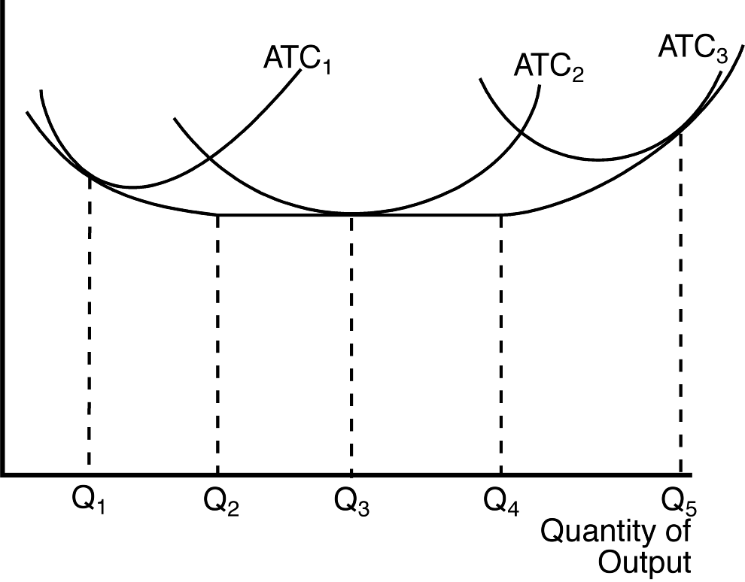
193. The three average total cost curves on the diagram correspond to three different
a. time horizons.
b. products.
c. firms.
d. factory sizes.
ANSWER: d. factory sizes.
TYPE: M DIFFICULTY: 2 SECTION: 13.4
194. The firm experiences economies of scale if it changes its level of output
a. from Q₁ to Q₂.
b. from Q₂ to Q₃.
c. from Q₃ to Q4.
d. from Q4 to Q5.
ANSWER: a. from Q1 to Q2.
TYPE: M DIFFICULTY: 2 SECTION: 13.4
195. The firm experiences diseconomies of scale if it changes its level of output
a. from Q1 to Q2.
b. from Q2 to Q3.
c. from Q3 to Q4.
d. from Q4 to Q5.
ANSWER: d. from Q4 to Q5.
TYPE: M DIFFICULTY: 2 SECTION: 13.4
196. The fundamental reason that marginal cost eventually rises as output increases is because of
a. economies of scale.
b. diseconomies of scale.
c. diminishing marginal product.
d. rising average fixed cost.
ANSWER: c. diminishing marginal product.
TYPE: M DIFFICULTY: 2 SECTION: 13.4
197. Tom owns a factory in which he has produced TVs for five years. He has kept track of his average total cost as his level of production varies. This information is summarized below:
Output Average Total Cost
10 $500
20 $400
30 $300
40 $400
50 $500
From this information we can conclude that
a. Tom’s factory exhibits both economies and diseconomies of scale.
b. Tom’s factory exhibits only diseconomies of scale.
c. Tom’s factory exhibits constant returns to scale.
d. None of the above are correct.
ANSWER: d. None of the above are correct.
TYPE: M DIFFICULTY: 3 SECTION: 13.4
198. Which of the following statements is false?
a. In the long run, there are no fixed costs.
b. Marginal cost is independent of fixed costs.
c. Economies of scale is a short-run concept.
d. Diminishing marginal product explains increasing marginal cost.
ANSWER: c. Economies of scale is a short-run concept.
TYPE: M DIFFICULTY: 2 SECTION: 13.4
True/False
1. Examination of the costs of production is unnecessary to the field of industrial organization.
ANSWER: F TYPE: TF DIFFICULTY: 2 SECTION: 13.1
2. Economists normally assume that people start their own businesses to help society maximize its income.
ANSWER: F TYPE: TF DIFFICULTY: 2 SECTION: 13.1
3. When economists speak of a firm’s costs, they are usually excluding the opportunity costs.
ANSWER: F TYPE: TF DIFFICULTY: 2 SECTION: 13.1
4. Economists and accountants usually disagree on the inclusion of implicit costs into the cost analysis of a firm.
ANSWER: T TYPE: TF DIFFICULTY: 1 SECTION: 13.1
5. Implicit costs are costs that do not require an outlay of money by the firm.
ANSWER: T TYPE: TF DIFFICULTY: 1 SECTION: 13.1
6. Accountants keep track of the money that flows into and out of firms.
ANSWER: T TYPE: TF DIFFICULTY: 1 SECTION: 13.1
7. Accountants often ignore implicit costs.
ANSWER: T TYPE: TF DIFFICULTY: 1 SECTION: 13.1
8. Economists and accountants both include forgone income as a cost to a small business owner.
ANSWER: F TYPE: TF DIFFICULTY: 2 SECTION: 13.1
9. Although economists and accountants treat many costs differently, they both treat the cost of capital the same.
ANSWER: F TYPE: TF DIFFICULTY: 2 SECTION: 13.1
10. In the long run, a factory is usually considered a fixed input.
ANSWER: F TYPE: TF DIFFICULTY: 2 SECTION: 13.2
11. When trying to understand the decision making process of different firms, economists assume that people think at the margin.
ANSWER: T TYPE: TF DIFFICULTY: 2 SECTION: 13.2
12. The shape of the total cost curve is unrelated to the shape of the production function.
ANSWER: F TYPE: TF DIFFICULTY: 2 SECTION: 13.2
13. Diminishing marginal product exists when the total cost curve becomes flatter as outputs increases.
ANSWER: F TYPE: TF DIFFICULTY: 2 SECTION: 13.3
14. Diminishing marginal product exists when the production function becomes flatter as inputs increase.
ANSWER: T TYPE: TF DIFFICULTY: 2 SECTION: 13.3
15. Several related measures of cost can be derived from a firm’s total cost.
ANSWER: T TYPE: TF DIFFICULTY: 2 SECTION: 13.3
16. Fixed costs are incurred even when a firm does not produce anything.
ANSWER: T TYPE: TF DIFFICULTY: 2 SECTION: 13.3
17. Variable costs usually change as the firm alters the quantity of output produced.
ANSWER: T TYPE: TF DIFFICULTY: 2 SECTION: 13.3
18. Variable costs equal fixed costs when nothing is produced.
ANSWER: F TYPE: TF DIFFICULTY: 2 SECTION: 13.3
19. The cost of producing an additional unit of a good is not the same as the average cost of the good.
ANSWER: T TYPE: TF DIFFICULTY: 2 SECTION: 13.3
20. Average variable cost is equal to total variable cost divided by quantity of output.
ANSWER: T TYPE: TF DIFFICULTY: 2 SECTION: 13.3
21. The average total cost curve is unaffected by diminishing marginal product.
ANSWER: F TYPE: TF DIFFICULTY: 2 SECTION: 13.3
22. The average total cost curve reflects the shape of both the average fixed cost and average variable cost curves.
ANSWER: T TYPE: TF DIFFICULTY: 2 SECTION: 13.3
23. If the marginal cost curve is rising, so is the average total cost curve.
ANSWER: F TYPE: TF DIFFICULTY: 2 SECTION: 13.3
24. The marginal cost curve intersects the average total cost curve at the minimum point of the average total cost curve.
ANSWER: T TYPE: TF DIFFICULTY: 2 SECTION: 13.3
25. A second or third worker may have a higher marginal product than the first worker in certain circumstances.
ANSWER: T TYPE: TF DIFFICULTY: 2 SECTION: 13.3
26. Assume Jack received all A’s in his classes last semester. If Jack gets all C’s in his classes this semester, his GPA may or may not fall.
ANSWER: T TYPE: TF DIFFICULTY: 3 SECTION: 13.3
27. Average total cost and marginal cost are merely ways to express information that is already contained in a firm's total cost.
ANSWER: T TYPE: TF DIFFICULTY: 2 SECTION: 13.3
28. Average total cost reveals how much total cost will change as the firm alters its level of production.
ANSWER: F TYPE: TF DIFFICULTY: 2 SECTION: 13.3
29. The shape of the marginal cost curve tells a producer something about the marginal product of her workers.
ANSWER: T TYPE: TF DIFFICULTY: 2 SECTION: 13.3
30. When average total cost rises if a producer either increases or decreases production, then the firm is said to be operating at efficient scale.
ANSWER: T TYPE: TF DIFFICULTY: 2 SECTION: 13.3
31. Fixed costs are those costs that remain fixed no matter how long the time horizon is.
ANSWER: F TYPE: TF DIFFICULTY: 2 SECTION: 13.4
32. Diseconomies of scale often arise because higher production levels allow specialization among workers.
ANSWER: F TYPE: TF DIFFICULTY: 2 SECTION: 13.4
33. The fact that many decisions are fixed in the short run but variable in the long run has little impact on the firm's cost curves.
ANSWER: F TYPE: TF DIFFICULTY: 2 SECTION: 13.4
34. In some cases, specialization allows larger factories to produce goods at a lower average cost than smaller factories.
ANSWER: T TYPE: TF DIFFICULTY: 2 SECTION: 13.4
35. The use of specialization to achieve economies of scale is one reason modern societies are as prosperous as they are.
ANSWER: T TYPE: TF DIFFICULTY: 2 SECTION: 13.4
36. As a firm moves along its long-run average cost curve, it is adjusting the size of its factory to the quantity of production.
ANSWER: T TYPE: TF DIFFICULTY: 2 SECTION: 13.4
37. Because of the greater flexibility that firms have in the long run, all short-run cost curves lie on or above the long-run curve.
ANSWER: T TYPE: TF DIFFICULTY: 2 SECTION: 13.4
38. There is general agreement among economists that the long-run time period exceeds one year.
ANSWER: F TYPE: TF DIFFICULTY: 2 SECTION: 13.4
39. Adam Smith's example of the pin factory demonstrates that economies of scale result from specialization.
ANSWER: T TYPE: TF DIFFICULTY: 2 SECTION: 13.4
SHORT ANSWER
1. What are opportunity costs? How do explicit and implicit costs relate to opportunity costs?
ANSWER: The opportunity cost of an item refers to all those things that must be forgone to acquire that item. Both explicit and implicit costs are included as opportunity costs.
TYPE: S DIFFICULTY: 2 SECTION: 13.1
2. A key difference between accountants and economists is their different treatment of the cost of capital. Does this cause an accountant’s estimate of total costs to be higher or lower than an economist’s estimate? Explain.
ANSWER: An accountant would not include the forgone interest income that the money could have earned elsewhere if it had not been invested in the business. Therefore, an accountant’s estimate of total cost will be less than an economist’s.
TYPE: S DIFFICULTY: 2 SECTION: 13.1
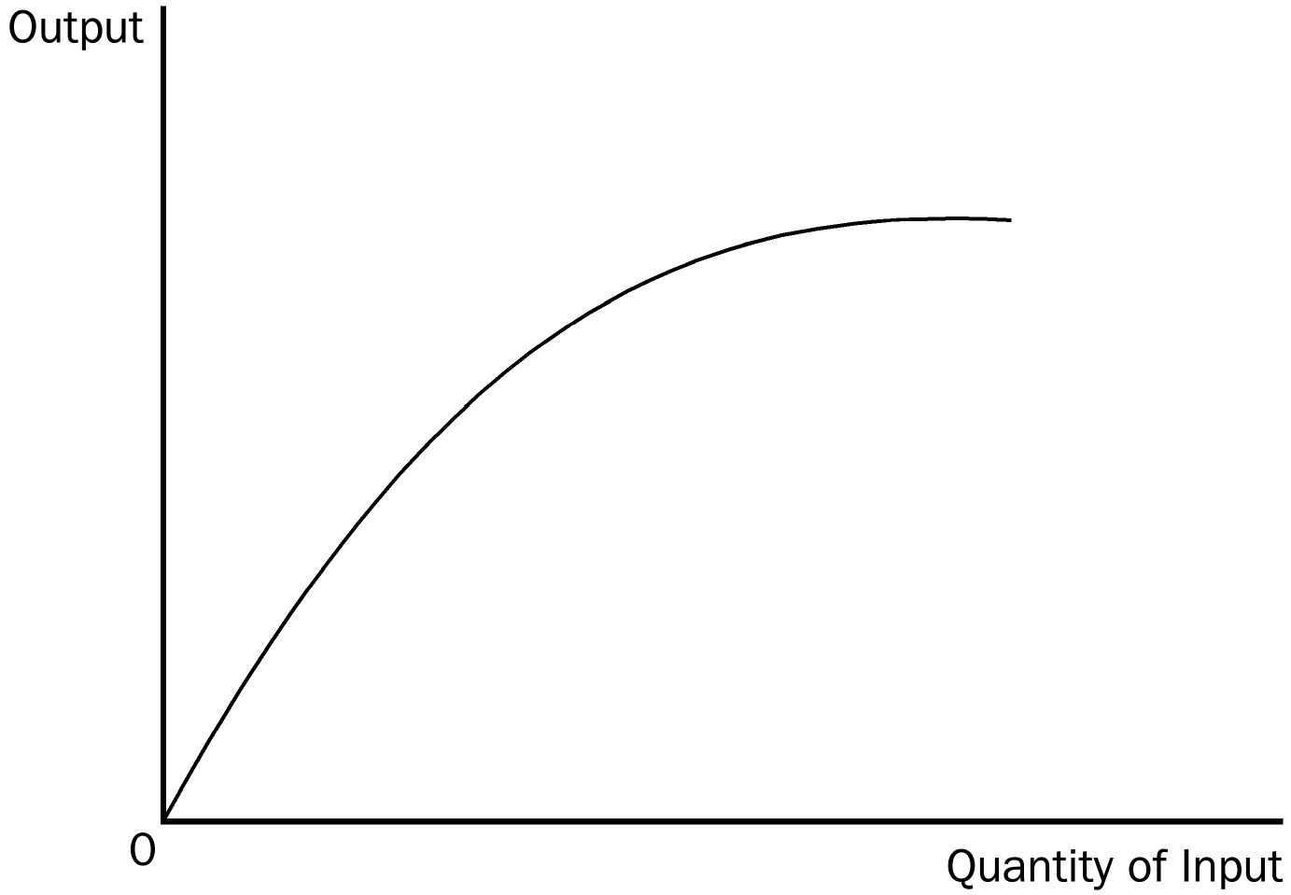
3. The production function depicts a relationship between which two variables? Also, draw a production function that exhibits diminishing marginal product.
ANSWER: It depicts a relationship between output and a given input. The graph should show output increasing, but at a decreasing rate as inputs increase.

TYPE: S DIFFICULTY: 2 SECTION: 13.2
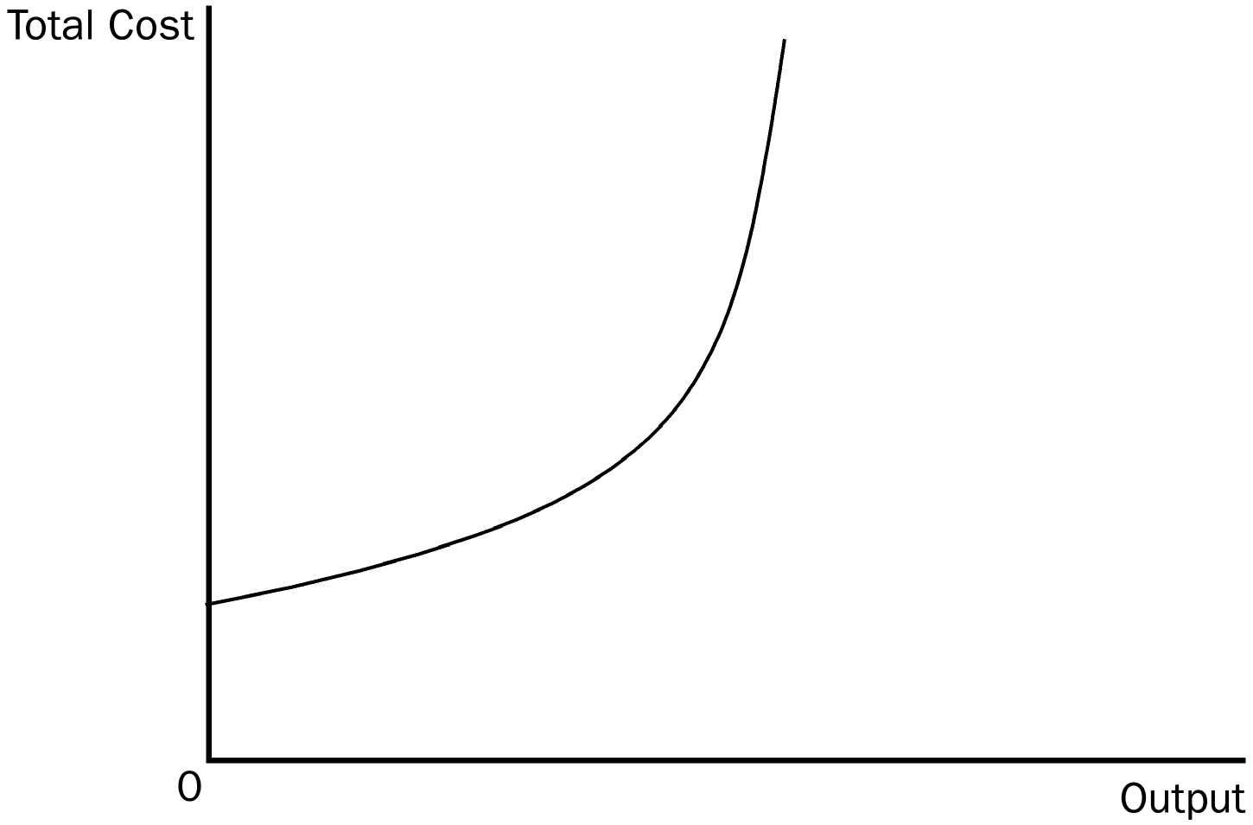
4. How would a production function that exhibits decreasing marginal product affect the shape of the total cost curve? Explain or draw a graph.
ANSWER: The total cost curve will increase at an increasing rate, or in other words, the total cost curve gets steeper as the amount produced rises.

TYPE: S DIFFICULTY: 2 SECTION: 13.3
5. What effect, if any, does diminishing marginal product have on the shape of the marginal cost curve?
ANSWER: Diminishing marginal product causes the marginal cost curve to rise.
TYPE: S DIFFICULTY: 2 SECTION: 13.3
6. Bob Edwards owns a bagel shop. Bob hires an economist who assesses the shape of the bagel shop’s average total cost (ATC) curve as a function of the number of bagels produced. The results indicate a U-shaped average total cost curve. Bob’s economist explains that ATC is U-shaped for two reasons. The first is the existence of diminishing marginal product, which causes it to rise. What would be the second reason? Assume that the marginal cost curve is linear. (Hint: The second reason relates to average fixed cost)
ANSWER: Average fixed cost always declines as output rises because fixed cost is being spread over a larger number of units, thus causing the average total cost curve to fall.
TYPE: S DIFFICULTY: 3 SECTION: 13.3
7. If the average total cost curve is falling, what is necessarily true of the marginal cost curve? If the average total cost curve is rising, what is necessarily true of the marginal cost curve?
ANSWER: When average total cost curve is falling it is necessarily above the marginal cost curve. If the average total cost curve is rising, it is necessarily below the marginal cost curve.
TYPE: S DIFFICULTY: 2 SECTION: 13.3
8. According to the mathematical laws that govern the relationship between average total cost and marginal cost, where must these two curves intersect?
ANSWER: The two curves will cross at the minimum point on the average total cost curve.
TYPE: S DIFFICULTY: 2 SECTION: 13.3

